2009 University CSOTY

Mona Jalili, a Biomedical Physiology and Kinesiology co-op student from Simon Fraser University. has been described by her co-op supervisor, Dr. Stephen Robinovitch (Canada Research Chair in Injury Prevention and Mobility Biomechanics), as having “strong intellect, organizational skills, scientific curiosity, drive and interpersonal skills”, along with “a natural aptitude for laboratory-based and clinical research”. As Mona nears graduation, she hopes to continue with further studies in pharmacy, a path that became clear to her through her participation in the co-op program. She notes: “my co-op journey has made it possible for me to balance education, volunteering, regular religious activities and work as a researcher, while helping me to find the answer to “What do I want to do with my life?”.

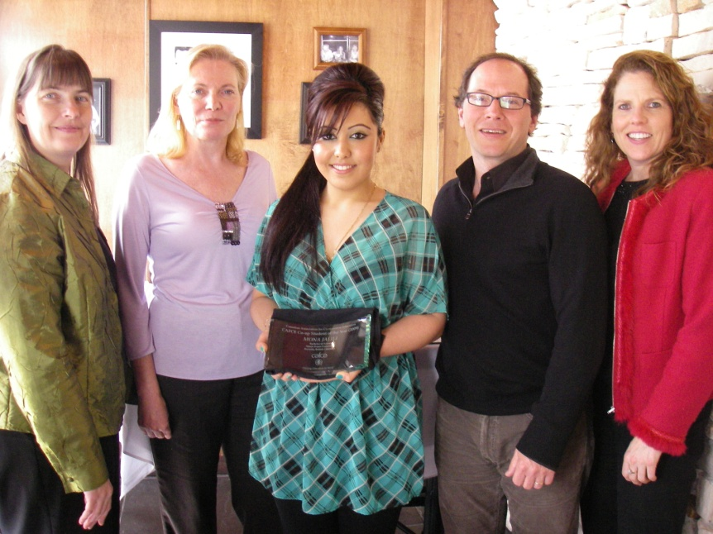
Left to right:

Gwen Litchfield, Program Manager, Science, Environment & Health Sciences Co-op, SFU

Muriel Klemetski, Director, Work Integrated Learning, SFU

Mona Jalili, Biomedical Physiology & Kinesiology Co-op Student, SFU

Dr. Stephen Robinovitch, Canada Research Chair in Injury Prevention and Mobility Biomechanics (Co-op Employer)

Darleen Bemister, Co-op Coordinator, Biomedical Physiology & Kinesiology Co-op Program, SFU

2009 College CSOTY

Lori-Beth Pentsa of the Conestoga College was nominated by Atria Networks, of Cambridge, and is the first co-op student ever hired by that firm. Her outstanding work-related achievements in her 8 months at Atria include single-handed management of their entire events and tradeshow calendar, providing key strategic contributions to the company’s direct-mail campaign which resulted in more than doubling of the expected revenue, acting as a main organizer of a very successful employee golf tournament, and numerous other feats. Lori-Beth has actively supported her co-op program by sharing her marketing co-op expertise with other students, is a Peer Tutor, is the recipient of the Conestoga Marketing Program Committee Advisory Award, and has participated in the Ontario Colleges Marketing Competition (OCMC) for the past two years, earning a Gold Medal and a Silver Medal .
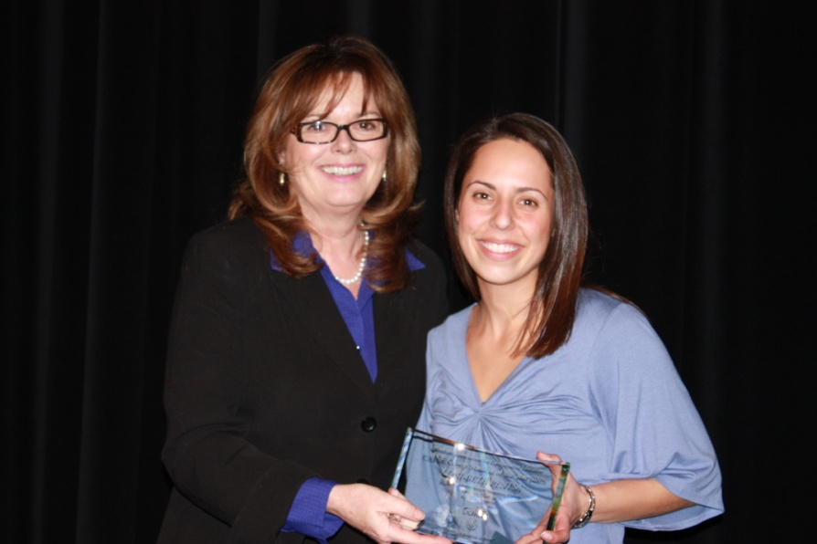

Left to right:

Lisa Whalen, Manager, Centre for Co-operative Education/Internship and Career Services
Georgian College (CAFCE Board of Directors)

Lori-Beth Pentsa, Marketing Co—op Program, Conestoga College

Honourable mentions were given to: Cristina Baptista-Concordia University, Roseanna Presutti-University of Waterloo, Siaw Yun Poi-University of Waterloo, Dusty Silvester-Camosun College, and, Katherine Williams-Camosun College

